Successive Differentiation

Find the nth derivative of the following functions:
1. 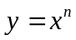.
2. y = 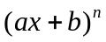.
3. 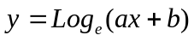.
4. 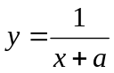
5. 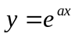.
6. 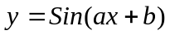.
7. 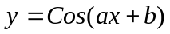.
8. 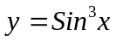.
9. If 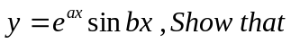 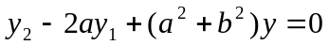
10. If 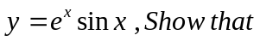 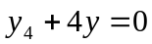

Taylor’s Theorem

Expand the following functions:
1. 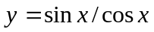 in the powers of 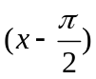
2. 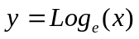 in the powers of 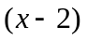
3. 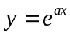 in the powers of 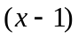

Maclaurine’s Series
Expand the followings:
1 in the powers of x
2 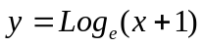 in the powers of x
3. 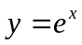 in the powers of x .

